**01 Getting Started**

**1) What is Node**:

Node.js is an open-source, cross-platform JavaScript run-time environment that executes JavaScript code outside of a browser.

We often use Node to build back-end services. This is also called API (Application Programming Interfaces). Node is ideal for building high-scalable, data-intensive and real-time application. Node is better for development for the following reasons.

1. Great for prototyping and agile development.
2. Superfast and highly scalable services.
3. Use in production in large company’s like PayPal, Uber, Netflix, Walmart, etc.
4. Node application using JavaScript. (Back-end, front-end everywhere JavaScript)
5. Cleaner and more consistent codebase
6. Large ecosystem of open-source libs

For example, in PayPal they rebuilt one of there Java and Spring application by using Node.js and they found that Node application was.

1. Built twice as fast with fewer people
2. 33% fewer lines of code
3. 40% fewer files
4. 2x request per second
5. 35% faster response time

So, Node is an excellent choice for building highly scalable services.

**2) Node Architecture**:

Before Node we use JavaScript only to build applications that runs inside a browser. Every browser has a JavaScript engine that takes our JavaScript code and convert them into machine code.

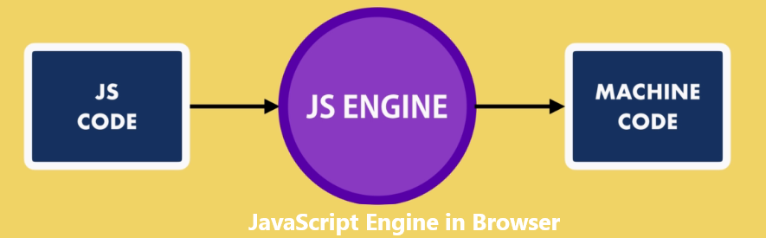

**Example of JavaScript Engine**:

1. Microsoft Edge -> Chakra
2. Mozilla Firefox -> SpiderMonkey
3. Google Chrome -> V8

After 2009 the only way to execute JavaScript code was inside a browser. In 2009 "Ryan Dahl" the creator of Node, came out with a brilliant idea. He wants to run JavaScript code outside the browser. He took Google V8 engine which is the faster JavaScript engine and embedded it with a C++ program and call that program Node.

Similar to a browser Node is a runtime environment for JavaScript code. It contains a JavaScript engine that can execute JavaScript code outside a browser.

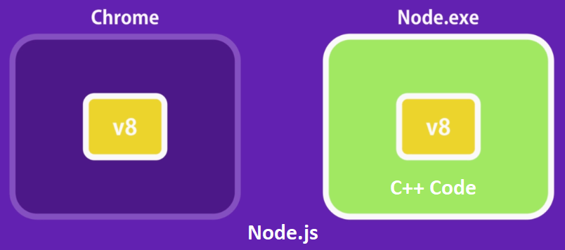

Node is a program that includes a V8 JavaScript engine with some additional modules that gives us capabilities not available inside browser. We can work with file system, networks and so on.

Both Node and Chrome share the same JavaScript engine but they provide different runtime environment for JavaScript.

Remember Node is not a programming language or a framework, it’s a runtime environment for run JavaScript code outside browser.

**3) How Node works**:

Node applications are highly-scalable because of the non-blocking or asynchronous nature of node.

JavaScript is asynchronous in nature and so is Node. Asynchronous programming is a design pattern which ensures the non-blocking code execution.

Non-blocking code do not prevent the execution of piece of code. In general, if we execute in Synchronous manner i.e. one after another, we unnecessarily stop the execution of those code which is not depended on the one you are executing.

Asynchronous does exactly opposite, asynchronous code executes without having any dependency and no order. This improves the system efficiency and throughput.

Asynchronous programming is great for faster execution of programs but it comes with price. That’s right, it’s difficult to program and most of the time we end up having callback hell scenario.

In Node a single thread is used to handle multiple request.

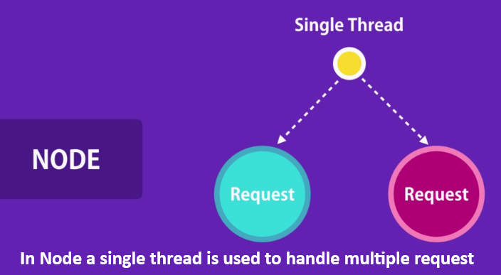

When we request, the single thread is used to handle the request. If we need to query a database our thread does not have to wait for the database for return the data. While the database is executing the query that thread will be use to serve another client.

When the database preparing the result, it puts a message what we call an "Event Queue". Node is continuously monitoring the queue in the background. When we find an event in this queue, it will take it out and process it. This kind of architecture makes node ideal for building application that include a lot of desk or network access.

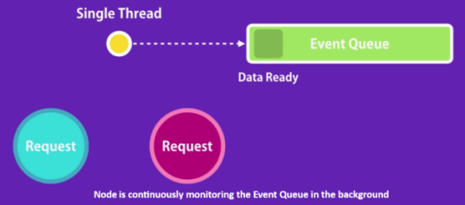

**4) Install Node**:

For working with Node first we have to install Node in our machine. For this we have to do the following thing.

1. Go to <https://nodejs.org/en/>
2. Download the LTS node version
3. Install Node in machine
4. After installation check node version "node --version"

**5) First Node Program**:

After install node in our machine the environment is ready and now to run node program, we have to do the following thing.

1. Create a directory (node-practice) in desktop and go to the directory

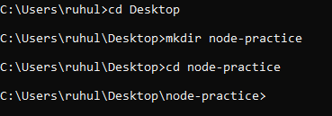.

1. Open the directory in "Visual Studio Code" and create a file name "app.js".

function sayHello(name) {

console.log("Hello: " + name);

}

sayHello("Ruhul");

1. Now to run this code go to the terminal and run the code "node app.js"



01 Getting Started